

Functional Requirements Document (FRD)
  - Customer Name – Job Number

Copyright© 2018, Oracle and/or its affiliates. All rights reserved.
Any reproduction or distribution of any part of this document without the prior written permission of Oracle + NetSuite is strictly prohibited.
The information included in this document is confidential and proprietary information of Oracle + NetSuite.
Version: March 3, 2022

Oracle + NetSuite
2955 Campus Drive, Suite 100
San Mateo, CA. 99403-2511

Project Information
Implementation Name | J910382 KEC Technologies, Inc. | Implementation Service - Fixed Bid
Customer Name (Number) | 8478971 KEC Technologies, Inc.
Job Name (Number) | J910382
Document Owner | Brady Onkka
Project Manager | Brady Onkka
Lead Developer | Ilan Daniele

Document Version History
Rev | Date | Author(s) | Change Summary
1.0 | 5/4/23 | Brady Onkka | Initial Draft

Table of Contents
1 Business needs 4
2 Impacted areas/modules [Optional as output] 4
3 Acceptance criteria 6
4 Solution proposal 6
5 Prerequisites 6
6 Assumptions 7
7 Constraints and limitations 7
8 Risks 8

Business needs
Client is looking to make changes to 2 My Account pages to make the pages easier for customers to use and minimize contacts to their sales/support team.
SCMA.
- Add Amount (field recurringamount) billed monthly and Billing Frequency (field frequency) to the table at the top of the page displaying Subscription information. Where do these fields come from?

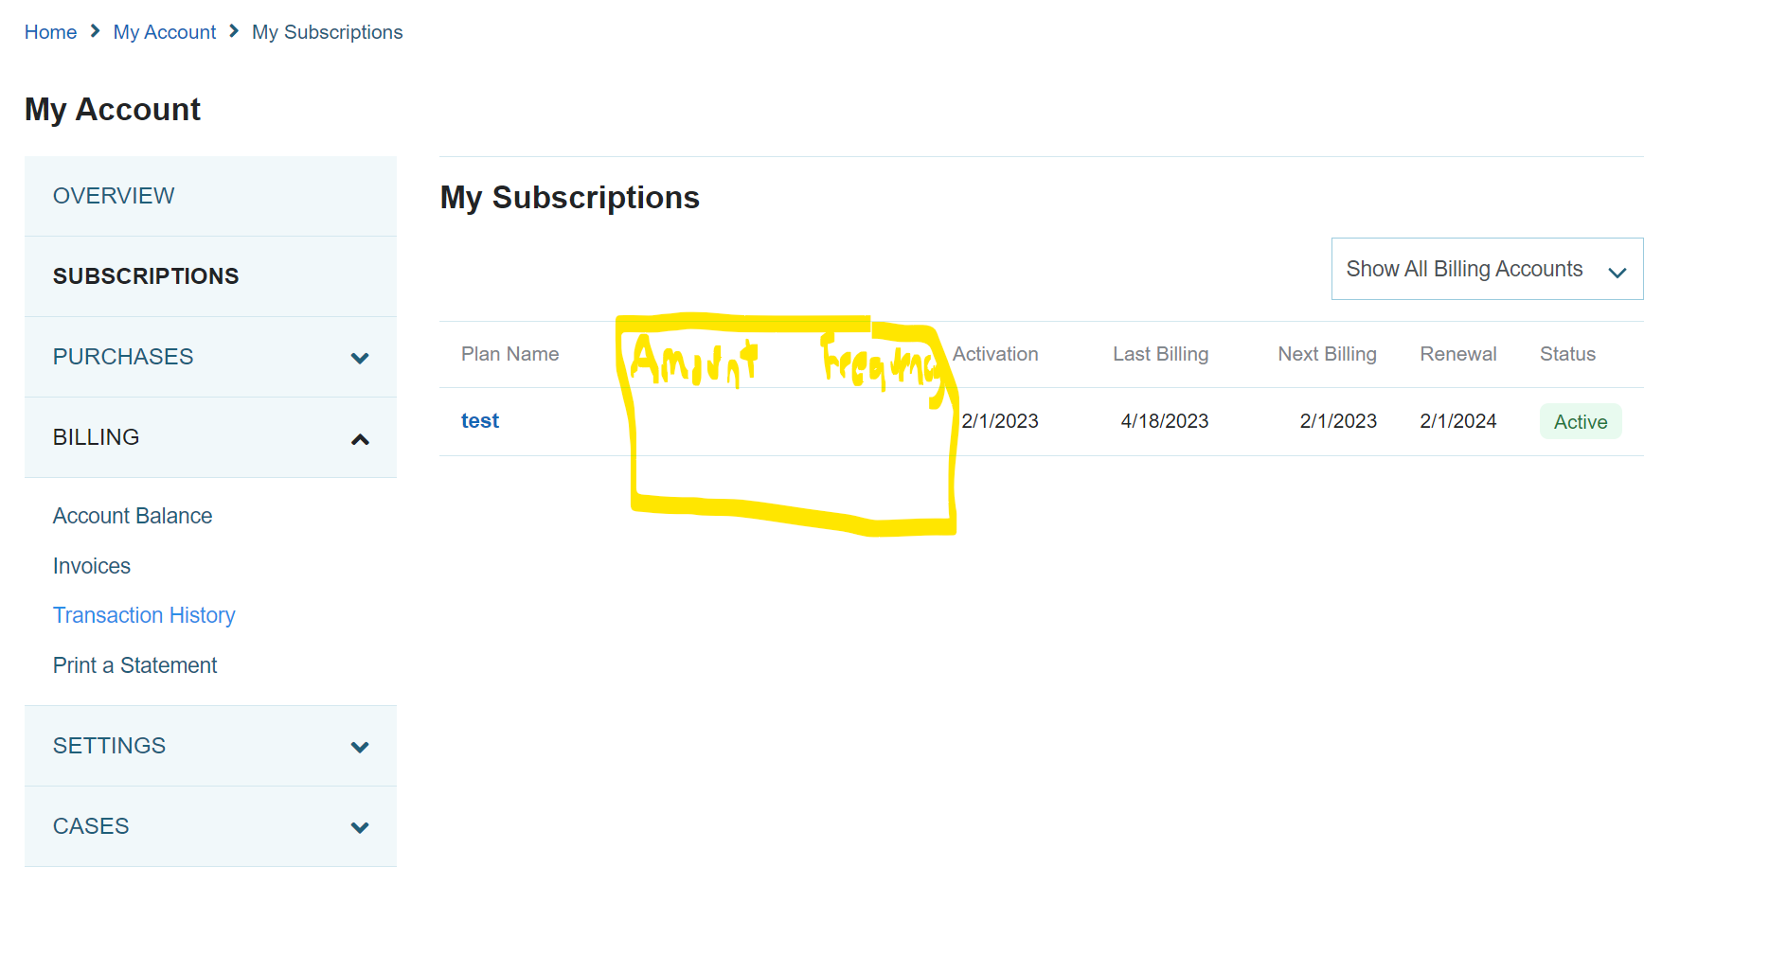
- Add Amount (field recurringamount) billed monthly to the top of the Plan page. This is the page that appears when you click on the Subscription Plan field on the above page.

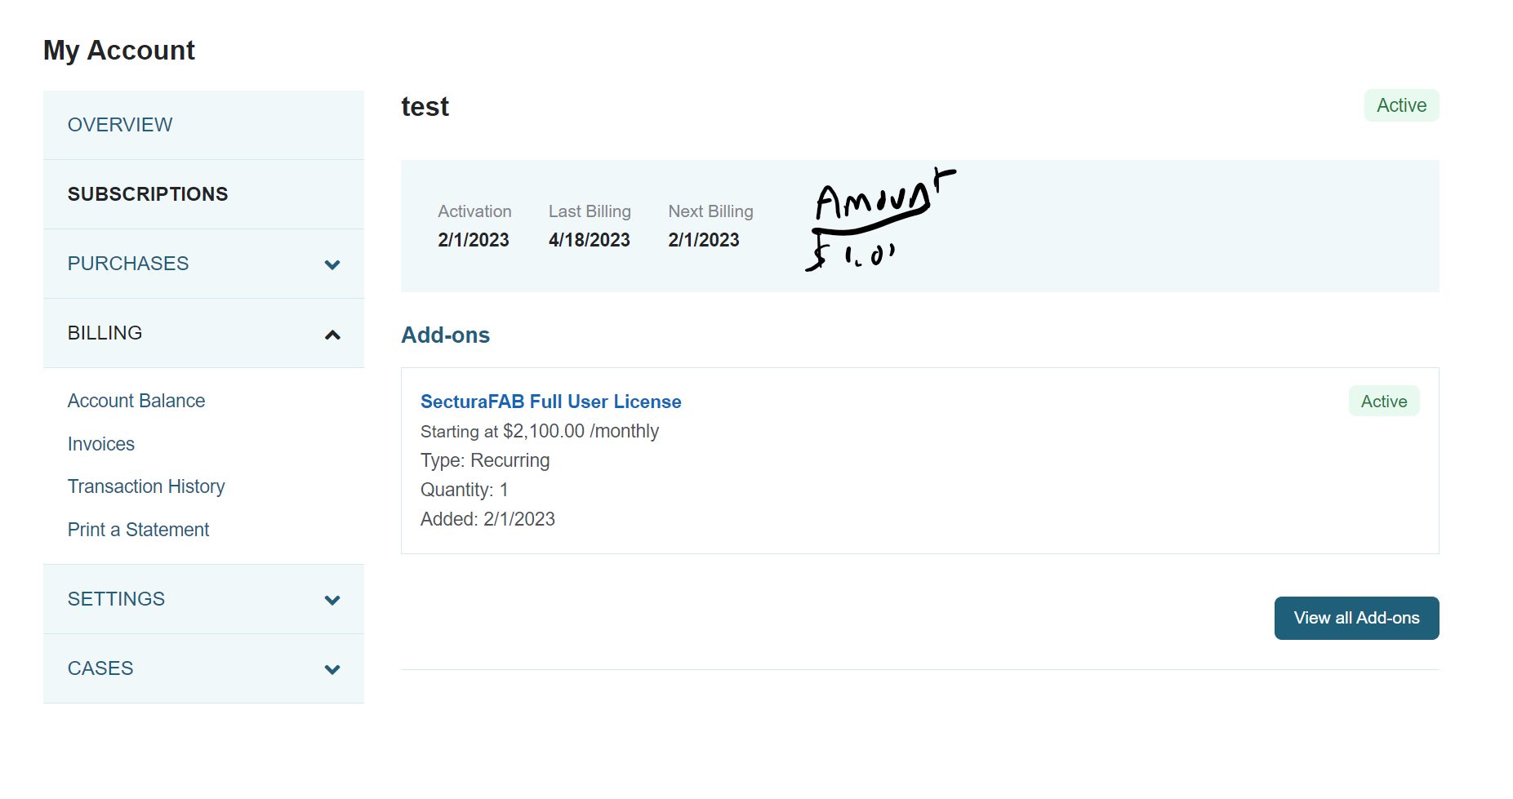

Impacted areas/modules [Optional as output]
Create two new pages within My Account to replace two existing pages.
- Display recurringamount on both the My Subscriptions page and the Plan Page within My Account.
- Display frequency just on My Subscriptions page within My Account.
- Changes are limited to My Account, specifically those pages connected to SuiteBillings Sunbscription service.

Acceptance criteria
- When viewing a subscription on My Sub page we will see the amount billed on each billing cycle, and the frequency or billing cycle.

Solution proposal

Prerequisites

Assumptions

Constraints and limitations

Risks

Oracle + NetSuite Professional Services and Customer are in agreement that the information documented above is accurate and representative of the customer’s business needs. This document will act as the basis for all subsequent implementation activities.
Document delivery date: MM/DD/YYYY

